Republic of the Philippines

PROVINCE OF ZAMBOANGA DEL NORTE

Municipality of Siayan

OFFICE OF THE SANGGUNIANG BAYAN

EXCERPT FROM THE MINUTES OF THE REGULAR SESSION OF THE SANGGUNIANG BAYAN OF SIAYAN, ZAMBOANGA DEL NORTE HELD AT THE MUNICIPAL SESSION HALL ON THE 10TH DAY OF JULY, 2017.

PRESENT:

Hon. Daisy A. Limbang, Presiding Officer, Municipal Vice Mayor
Hon. Raul P. Dominise, Presiding Officer Pro-Tempore, Sangguniang Bayan Member
Hon. Emelyn P. Alumbre, Majority Floor Leader, -do-
Hon. Nadine R. Pollescas, Minority Floor Leader, -do-
Hon. Norma R. Labastida, -do-
Hon. Primitivo D. Castillo, Asst. Majority Floor Leader, -do-
Hon. Ma. Roselyn G. Secretario, -do-
Hon. Oliver A. Romero, -do-
Hon. Vanessa Lyn B. Atuy, -do-
ABSENT:
Hon. Alberto J. Bongcawel, LIGA President (O.B.) -do-

--------------------------------------------------------------------------------------------------------------------------------------------
“MUNICIPAL ORDINANCE N0. 17-07
Series of 2017

AN ORDINANCE ENACTING THE GENDER AND DEVELOPMENT CODE OF THE MUNICIPALITY OF SIAYAN, ZAMBOANGA DEL NORTE AND FOR OTHER PURPOSES.
Be it ordained by the Sangguniang Bayan of Siayan, Zamboanga del Norte session assembled.
CHAPTER I
ARTICLE I
GENERAL PROVISIONS

SECTION 1. Title. This ordinance shall be known as” GENDER AND DEVELOPMENT CODE’ of the Municipality of Siayan, Zamboanga del Norte and shall hereinafter be referred to as the GAD CODE.

SECTION 2. Statement of Policy. The Code formulation is anchored on R.A No. 9262” Anti Violence against Women and Their Children Act of 2004, and the Constitution which emphasizes and preserves the different rights of the individuals or its citizenry. Several laws that may serve as bases of references are (R.A No. 7192. The Women in Nation- Building (WIN); (R.A.6725; An Act Strengthening the Prohibition on Discrimination against Women); (R.A 7877; The Anti- Sexual Harassment against Women); (R.A 9208; The Anti- Trafficking in Person of 2003); (R.A 7610; Special Protection of Children against Child Abuse and Exploitation and Discrimination Act.)

The Local Government Unit adheres to the conviction that it is only by addressing the specific needs of men, women as well as their children, the elderly, the differently able persons, and the indigenous people, or being gender-responsive, that the quality of life is enhanced and fully enjoyed.

Based on this premise, the Local Government Unit adopts a policy direction to formulate programs and strategies, among others, that shall:

- The Local Government Unit shall heighten advocacy work on mainstreaming gender concerns in sectoral development plans, policies and programs.
- The Local Government Unit shall strengthen governmental and non-governmental partnership to maximize the effectiveness of the programs and services addressing gender and development concerns.
- The Local Government Unit shall sustain commitment to capacity building and women empowerment to increase numbers of women in decision and policy-making posts in the locality.
- The Local Government Unit shall provide gender-responsiveness, relief and rehabilitation programs with special focus on the needs of women, senior citizens, children and differently able persons.
- The Local Government Unit shall encourage, support and expand the participation of women in the planning implementation, monitoring and evaluation of development programs and projects.
- The Local Government Unit shall establish a cooperative or multi-purpose in different organization that will cater to and mitigate the financial as well as economic problems of the members as poverty alleviation strategy.

SECTION 3. Definition of Terms. The following terms or phrase as used in this Code shall mean as:

- LOCAL GOVERNMENT UNIT refers to the local government of the Municipality of Siayan, Zamboanga del Norte.

- GENDER is socially learned behavior and expectations associated with two sexes. Thus, whereas the maleness or femaleness is biological facts, masculinity and feminity are culturally construed attributes. It also refers to the socially differentiated roles and characteristics attributed by a given culture to women and men.

- GENDER AND DEVELOPMENT (GAD) is the development perspective which encourages the equal participation or contribution of women and men in all aspect/sectors of development.

- SENIOR CITIZENS are persons above 60 years old as differentiated from minors or children.

- MINORS OR CHILDREN are person below 18 years of age who are unable to fully take care of themselves from abuse, neglect, cruelty, exploitation. or discrimination.

- DIFFERENTLY ABLE PERSONS are survivors of physical impairments that have differentiated needs and potentials.

- INDIGENOUS PEOPLE known as Subanen having a set of specific rights based on their historical ties to a particular territory, and their cultural or historical distinctiveness from other populations that are often politically dominant.

- MAINSTREAMING is an integration or inclusion into all forms of endeavors. Programs, project men and women concern and needs.

- VIOLENCE AGAINST WOMEN as defined by R.A No. 9262. it refers to any gender-based violence which may result in physical, sexual, psychological suffering or economic abuse. This consists of:

- PHYSICAL VIOLENCE are acts that include bodily or physical harm.

- SEXUAL VIOLENCE are acts committed against a woman or her child. This includes:

(2.1) RAPE, SEXUAL HARASSMENT, ACTS OF LASCIVIOUSNESS is treating a woman or her child as a sex object. Making demeaning and sexually suggestive remarks, physically attacking the sexual parts of the victim’s body forcing her or him to watch obscene publication and indecent movies forcing the wife to live in a conjugal home or sleep together in the room with the abuser.

(2.2) PSYCHOLOGICAL VIOLENCE is an act or omission causing likely to cause mental or emotional suffering of the victim such as intimidation harassment , stalking , damage to property, public ridicule or humiliation repeated verbal abuse and marital infidelity.

(2.3) ECONOMIC ABUSE is an act that attempt to make a financially dependent as withdrawal of financial support or a preventing the victim from engaging in any legitimate profession, occupation or activity. Deprivation or or threat of deprivation of financial resources and the right to use and enjoyment of the conjugal community or property owned in common and destroying household property

- BATTERY is inflecting physical harm upon the women or a child resulting in physical, psychological and emotional distress.

- STALKING is an intentional act committed by a person who knowingly and without lawful jurisdiction follows the woman of her child under surveillance directly or indirectly.
- PORNOGRAPHY is written, graphic or other forms of communication intended to excite lascivious feelings.
- PROSTITUTION is a sale, purchase and exchange of women and minor for sexual exploitation for cash profit or other economic considerations by an individual.

- REPRODUCTIVE HEALTH as defined in the International Conference on Population and Development and World health Organization (WHO) and affirmed in Beijing Conference, is a state of complete physical, mental and social well being and not merely the absence of disease and infirmity, in all matters relating to the reproductive system and to its functions and process. It includes ten (10) elements which are:

- Maternal and Child Health and Nutrition
- Family Planning
- Prevention and Treatment of Reproductive Tract Infection (RTI) including STD, HIV and AIDS
- Prevention and Management of Abortion Complication
- Education and Counseling on Sexuality and Sexual Health
- Breast and Reproductive Tract Cancer and other Gynecological Conditions
- Prevention and Treatment of Infertility Sexual Disorder
- Men’s Reproductive Health
- Violence Against Women
- Women’s Reproductive Health

- WORST FORMS OF CHILD LABOR as in the Municipality of Siayan, two forms of worst child which exist are:

- DOMESTIC WORK- employment of children below 18 years of age as domestic helpers commonly termed as “House helpers” or “Maids’;

- CONSTRUCTION HELPER – employment of children below 18 years old carrying heavy loads of cement, sand and gravel, lumber, steel bars, etc.

ARTICLE II
GENDER AND DEVELOPMENT PROGRAMS
SECTION 1. Data Bank/ Gender Studies. The Local Government Unit shall see to it that a sufficient amount shall be allotted to gender-related documentation and researches that shall form part of the municipality based programs development.
SECTION 2. Sufficient Budget for Basic Social Services. The Local Government Unit shall apportion sufficient amount necessary to undertake the basic social services for all extremely difficult circumstances shall be allocated from any available source of funds.
SECTION 3. Community – based Environment Plans and Programs Men, Women and Children shall participate in pollution control, zero waste technology development and management, nursery development and forest preservation.
SECTION 4. Monitoring of the implementation of laws, policies on women and children particularly the Anti-Rape Law, Women in Development and Nation Building and Child Labor 101 shall be continuously and strictly undertaken by the Local Government Unit.
SECTION 5. Development of Great Women Project for sustaining and tracking the progress of gender mainstreaming efforts and gender responsive programs and project in the municipality shall be enacted and implemented by the Local Government Unit.
SECTION 6. Special Training for Lupong Tagapamayapa. The Local Government Unit shall conduct a special paralegal training for Lupong Tagapamayapa along gender question and related matters.
SECTION 7. Training on skills and livelihood projects. Women and children shall be given opportunity to acquire and skills development such as those related to science and technology.
SECTION 8. Establishing a cooperative in women organization which shall generate small business enterprises for members.

SECTION 9. Integrated Gender-sensitivity and Environment Friendly Plan shall be established to:

- Maintain and follow-up the solid waste management especially the regulation and selling of plastic bags.
- Preserve the protected water shed areas and forests.

ARTICLE III

SUPPORT SERVICES

SECTION 1. The Municipal Gender and Development Focal Point System Executive Committee shall be created through Executive Order to be issued by the Municipal Mayor. The Council will be composed of duly accredited government organization (POs) and Non- Government organizations (NGOs) operating within the municipality that shall serve as the coordinating and advisory body of the Municipality Government in the implementation of the Functions, power and duties prescribed in this code. The membership of Municipal Gender and Development Focal Point System Executive Committee shall be determined by the Mayor but not limited to Pos and NGO operating within the Municipality.

SECTION 2. The Office of the Women and Senior Citizen and Child-Friendly Locality known as GAD Office shall be established by the Local Government Unit.

SECTION 3. Gender and Development (GAD) Focal point person in the office of the Mayor, who is vital in gender mainstreaming and establishing institutional mechanism that will facilitate and sustain the implementation of R.A 7192- Women in the Nation Building shall be appointed.

SECTION 4. Women’s and Children’s Desks (WCDs). The local government shall establish and maintain the WCDs handled by Women Police Officer duly trained for the purpose. The police station shall have a separate WCD room.

SECTION 5. Role o f the Female Police Officer. Complaints on battering and other forms of abuse against women and children shall be handled by female officer in the municipality whose character and credibility do not violate the accepted standards in handling such cases.

SECTION 6. Municipality Council for the Protection of Children (MCPC) shall be created under the office of the Municipal Mayor compliance with the provisions of R.A 7192 otherwise known as Women in Development and Nation Building and R. A 7610- Special Protection of Children against Child Abuse, Exploitation and Discrimination Act.

SECTION 7. Women Welfare and Child-Friendly Locality Plans shall be established under the Municipal Social Welfare Development Office to cater to the problems and concerns of depressed families especially those by natural and man calamities.

SECTION 8. Committee on Decorum and Investigation (COD) looks into the implementation of R.A No. 7877 known as Anti-harassment Act of 1995 and helps protect every individual working in public sectors as provided and promulgated by the CSC Resolution No. 01-0940 for the Administrative Disciplinary Rules on Sexual Harassment Cases in the government sectors.

SECTION 9. Alternative Learning System (ALS) formerly the Non-Formal Education (NFE) The ALS provide literacy, continuing education, and vocational training to out-of –school youths and adults who are interested to pursue their knowledge and skills in the various fields of human endeavor.

SECTION 10. Sentrong Sigla. This is the program of the Rural Health Unit which provided health services through procurement of complete facilities, proper recording and other related activities.

SECTION 11. Advocacy and Participation Scheme of all Sectors. All sectors society shall be involved in the planning, implementation, reporting, monitoring and evaluation of GAD programs and projects.

SECTION 12. Rapid Community Based Monitoring System (RCBMS). The local government shall conduct an annual survey of households, establishments, institutions employing women in the Municipality to look into their status, to monitor cases of sexual harassment, sexual abuse and other forms of maltreatment. Employers, owners, or administrators must provide recreation/day –off depending on the condition mutually agreed upon by both parties.

ARTICLE IV
POLITICAL AND PUBLIC SPHERES OF ADULTS AND CHILDREN

SECTION 1. Declaration of March 8 as Women’s Day by the United Nation. Through an issuance of a Proclamation Order by the Municipal Mayor there shall be a municipal level set of activities for women to increase their level of awareness and critical consciousness on the issues affecting them.

SECTION 2. International Day of action for Women’s Health. The local government shall cause the celebration of this day of action for women health where issues and concerns relative to the protection of Women shall be examined, deliberated projects, and government’s action should be sought.

SECTION 3. Observance of the month of July as Nutrition Month All sectors of society are enjoined to undertake activities to enhance their nutritional and health status.

SECTION 4. Bloodletting Day August 1of the year in cooperation with the National Red Cross shall be set for bloodletting among the people to accumulate the pool of blood.

SECTION 5. Pangase Festival. This is one among the activities undertaken during the annual celebration of foundation day of municipality where cultural presentation are presented during the 12-17 of June.

ARTICLE V

LABOR AND EMPLOYMENT

SECTION 1. Equal Access to Employment, Training and Promotion. No one shall be denied of employment opportunity on account of gender, age, ethnicity, creed or religion as prescribed in the Labor Code as amended by R.A. 6425. Likewise, no one shall be denied of training and promotion.

SECTION 2. Wage and Fringe Benefits. Every Employer shall comply with the minimum wage as prescribed by the Wage Board and shall grant all benefits to all employees such as maternity/paternity leave, sick and vacation leave, retirement termination and other fringe benefits provided by law such as 13th month pay/bonus, extra cash gift ( ECG ), etc.

SECTION 3. Facilities and Support Systems for all employees and clients. The local government shall ensure the safety and health women employees as a such may establish separate toilet rooms, lavatories, and lounge for men and women and provide at least a dressing room in public places.

SECTION 4. Setting up of Grievance Machinery. A committee shall be set up by the Committee on Decorum and Investigation to act on complaints related to sexual harassment and a grievance procedure must be installed in every agency/office.

SECTION 5. Gender-Sensitive Physical Plan. A physical plan appropriate for gender-sensitive environment shall be adopted by all officers, agencies and establishments which shall help prevent sexual harassment, sexual abuse and other forms of maltreatments in the workplaces.

SECTION 6. Assistance Program. The Local Government of Siayan in cooperation with the Department of Labor and Employment (DOLE), the Technical Education and Skills Development Authority (TESDA), Department of Trade and Industry (DTI), Department of Science and Technology (DOST) Department of Social Welfare and Development (DSWD) NGAs and NGOs, etc, shall endeavor to assist poor but deserving students, the unemployment and underemployment in securing gainful employment.

ARTICLE VI

EDUCATION RIGHT

SECTION 1. Non-Formal Educational Classes. In cooperation with the Department of Education (DepEd) and TESDA, and other concerned government agencies, non- formal- education classes shall have:

- Literacy Program – to be opened to out-of-school youths who have not finished Grade VI or those who have not entered Kindergarten or Grade I classes.
- Continuing Education – professional or non-professional persons can enroll in this program to enhance their skills and knowledge in vocational activities.
SECTION 2. Scholarship Program. The local government shall provide this scholarship program for the poor but deserving students in elementary, high schools, colleges and universities located within the jurisdiction of the municipality.

ARTICLE VII

HEALTH BUDGET

SECTION 1. Budget for Women’s Health. The amount shall be integrated with GAD’s budget, which includes women, senior citizen, and children who would be divided equally among them whichever amount as been allocated, for health, nutrition and other services.

SECTION 2. Intensification of Health Care Delivery System. Quality health care and services that are not discriminatory on account of their gender, age, sex, religion and ethnicity shall be intensified and implemented.

SECTION 3. Primary Health Care Delivery. In consonance with the Department of Health Thrust, the local government shall strengthen the Primary Health Care and 24 hours emergency clinic in the context of reproductive health other emergencies.

SECTION 4. Protection against Drug Abuse. This shall be sustained and monitored by the PNP, MADAC, BADAC and Municipal Gender and Development Pocal Point System Executive Committee for the protection against drug abuse and proliferation of elicit drugs.

SECTION 5. Access to Safe Water. All barangays shall endeavor to provide easy access to safe water supply. Appropriate water systems shall be installed in order to ease women’s workloads as well as minimized women and children in fetching water for household use from a distant source.

SECTION 6. Child Development Centers. These shall be set-up in almost all barangays in support of children between 3 and 5 years old. Incentives shall be extended to Child Development Workers/Teachers to increase their honoraria.

CHAPTER II

CASES | PENALTY
SECTION 1  a.1.Establish or carry a business for the purpose of exploiting women for purposes of sex slavery, sex trade, sex tours and other immoral activities.  a.2.Pornography. Advertise, publish, print or distribute, or cause the advertisement, publication or distribution of any brochure, flyers or propaganda material to promote the above-mentioned prohibited acts.  a.3. Solicit, enlist or attract/induce any women to join any club ,organization whose object is to math women for marriage to foreigners.  b. To buy or sale a woman for any of her body parts.  c. To threaten or use violence and force a woman to become a mail-order bride. | Imprisonment of six (6) months or a fine of P2,500.00 or both at the discretion of the court without prejudice to the filing of appropriate cases under the national penal laws.
SECTION 2. Other Forms of Trafficking in Women. Any encourages, influence or recruits a woman to work abroad or locally for a particular job on a promise of a fee, instead forced and engaged in prostitution, domestic help or other odd jobs. | Imprisonment of six (6) months or a fine of P2,500.00 or both at the discretion of the court, without prejudice to the filing of appropriate cases under the national penal laws.
SECTION 3. Other form of sexual harassment other than the definition provided by R.A. 7877 otherwise known as the Anti- Harassment Act of 1995, the following constitute sexual harassment:  - Persistent telling of offensive jokes such as green jokes or other analogous statements to someone who finds them offensive and humiliating;  - Taunting a person with constant talk about sex and sexual innuendoes;  - Interrogating someone about their sexual activities except in medical or physical examination purposes;  - Making offensive hand or body gestures at someone;  - Repeatedly asking for dates despite verbal rejection;  - Staring or leering maliciously;  - Touching, pinching or brushing up against someone’s body unnecessarily or deliberately;  - Hissing or embracing someone against their will;  - Requesting sequel forms in exchange for good grade, obtaining a good job, promotion;  - Cursing, whistling or calling a woman in public with words having dirty connotations or implications which ridicule, humiliate or embarrass a woman;  - Requiring women to wear suggestive or provocative attire during interviews such as job hiring or promotion. | Commission of one of these acts be subjected to imprisonment of one week to six (6) months or a fine of P1,000.00 to P2,000.00 or both at the discretion of the court, without prejudice to the filing of appropriate cases under the national penal laws.
SECTION 4. Battering | Imprisonment of one (1) week to six (6) months or a fine of P1,000.00 toP2,000.00., without prejudice to the filing of appropriate cases under the national penal laws.
SECTION 5. Orientation on Sexual Harassment. All government agencies shall conduct orientation or sexual harassment | Failure to comply constitute a cause for administrative discipline or a fine of P2,500.00. without prejudice to the filing of appropriate cases under the national penal laws
SECTION 6. Reproductive Health Services for All. | Non- compliance P2,500.00 for heads.
SECTION 7. Worst Form of Child Labor:  1.Domestic Work/Helper | According to DOLE or child Labor Law.
SECTION 8. Environment and Solid Waste Management and cutting down of century-old trees. | DENR Local Government Sanction.
CHAPTER III

ARTICLE I
MISCELLANEOUS PROVISIONS

SECTION 1. The GAD Council as duly constituted shall assume and exercise the functions powers and duties as prescribed in this Code.

SECTION 2. Funding. An amount as maybe necessary to implement the provisions of this Code is hereby appropriated from any available sources in the general fund of the municipality in the pursuance of this Code subject to the existing laws, rules and issuances.

ARTICLE II
FINAL PROVISIONS

SECTION 1. Separability Clause. If for any reason, any portion or provisions of this Code is declared unconstitutional or invalid, the other sections or provisions hereby which are not affected thereby shall continues to be in full force and effect.

SECTION 2. Applicability of other laws, rules and regulations. On matters not provided for in this Code, any existing applicable laws, corresponding implementing rules, regulations, and relevant issuances issued therefore shall apply in suppletory manner.
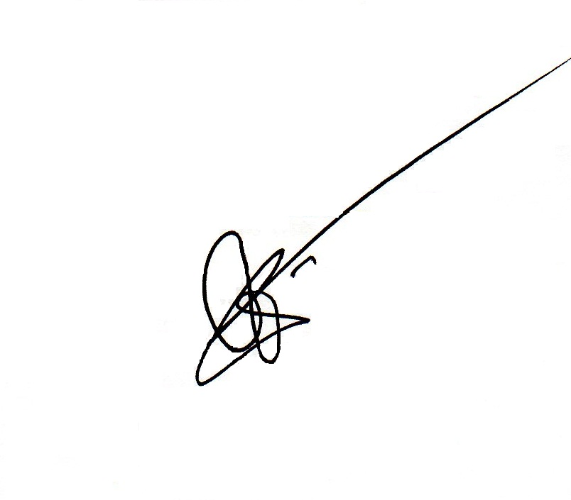
SECTION 3. Effectivity Clause. This Code shall take effect fifteen (15) days after its posting/publication

Enacted this 10th day of July, 2017.
-------------------------------------------------------------------------------------
I HEREBY CERTIFY to the correctness of the foregoing ordinance.

MARCELO S. EGUANAN
Local Legislative Staff Officer II
(Secretary to the Sanggunian – Des.)

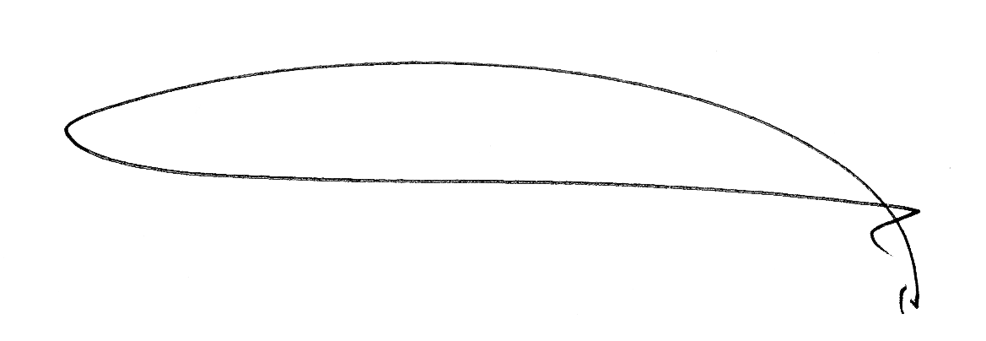
CERTIFIED CORRECT
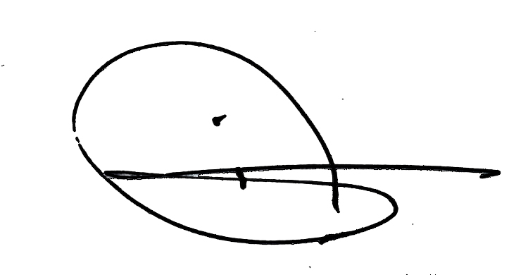
AS TO ITS PASSAGE:

DAISY A. LIMBANG
Municipal Vice Mayor
(Presiding Officer)
APPROVED:

FLORA L. VILLAROSA
Municipal Mayor

Date: ______________

